SUMMARY OF QUALIFICATIONS

Dedicated and enthusiastic information technology professional with significant knowledge and experience in undertaking PHP Code developing, MySQL / SQL programming, and related highly technical duties for clients to improve system stability, functionality, and efficiency. Quick to become familiar with the latest technologies and industry developments, while demonstrating a logical and analytical approach to solving complex problems and issues. Possesses excellent interpersonal and communication skills and the ability to develop and maintain positive internal and external relationships. Enjoys being part of a successful and productive team at TOMAHAWK, NZ and thrives in highly pressurised and challenging work environment.

Core Competencies/Areas of Expertise

• Laravel • PHP 7 • JavaScript • C Programming • Reletional Database (MySQL Queries) • HTML 5 • Responsive CSS • SCSS • OOP concepts and practical • Wordpress • Communication • Apache • XAMP • WAMP • GIT • GITHUB • Bootstrap • CMS • Scrum Master

• cloudflare DNS / Hosting • Domain Setup • JQuery

SKILLS PROFILE

Knowledge of PHP developing, programming, and related technical areas
- Possesses a Master of Information Technology degree from Dharmsinh Desai University and a Bachelor of Information Technology degree from Ganpat University, both in India.
- Worked as a Junior PHP Developer with 9 Series Private Ltd in India from 2016 to 2017.

Technical support and customer service
- Experienced in resolving highly technical issues facing clients, including MySQL queries and PHP programming, as well as defect and bug recovery in programming and designing.
- Handles clients with decorum and respect.

Communication and teamwork
- Works well with both staff and external technical personnel to deliver value to clients.
- Communicated regularly with the Team lead and other staff members on the team, and often with the client as well, while working in the previous position of PHP Developer in India; accustomed to regular oral and written communication over complex issues that arise.

RELEVANT PROFESSIONAL EXPERIENCE

TOMHAWK, NZ. Mar 2019 – Present
PHP Web Developer
- Developing Websites using PHP, MySQL, Ajax for the backend and jQuery, Bootstrap, XML, SCSS, CSS, Vue Js and JavaScript for frontend
- Writing clean structured, well-documented code, reviewing current code and fixing bug.
- Working on our own standard CMS and Bespoke CMS integrated with the latest technology.
- Wrote and executed MYSQL queries to perform the back-end connection with the driver information database
- Resolving cross browser compatibility issues.
- Developing and managing own projects independently
- Create, Manage Repo on GIT and Git Hub via desktop application and manually.
- Taking part in daily stand-ups and regular team-wide meetings to discuss current and upcoming tasks.
- Reporting to the team and stakeholders on progress, timelines and road blocks.
- Structure Projects into small, actionable tasks to deliver on time.

Key Achievements
- Executed tasks to the satisfaction of clients
- Became a scrum master

Developed Projects
- Over the top helicopter https://www.flynz.co.nz/
- Flame Grill https://www.flamegrill.co.nz/

9 SERIES PRIVATE LTD, India • 2016 – 2017
Junior PHP Developer
- Undertook Project developing in Laravel and CodeIgniter.
- Gathered requirements from Team Lead and clients after that analysed them for developing perspective.
- Developed and executed project and solve bugs from them.
- Wrote and executed MYSQL queries to perform the back-end connection with the driver information database.
- Coordinated testing resources and performed other duties as required.
- Sharing updated modules on GIT and modification on it.

Key Achievements:
- Successfully ran Projects of both Laravel and Core PHP Programming.
- Executed tasks to the satisfaction of clients.
- Engaged projects in exciting challenging environment.

EDUCATION AND PROFESSIONAL DEVELOPMENT

DHARMSINH DESAI UNIVERSITY, India
Master of Information Technology
- Including Software Design and Engineering

GANPAT UNIVERSITY, India
Bachelor of Information Technology
- Including units in Communication Skills, Computer System Organisation, Internet Programming, Object-Oriented Programming, DBMS-1, Operating Systems, Data Structure, DBMS-2, JAVA, Advanced JAVA, Object-Oriented Analysis and Design, and Software Engineering, PHP

COURSES/ CERTIFICATIONS/ LICENSES

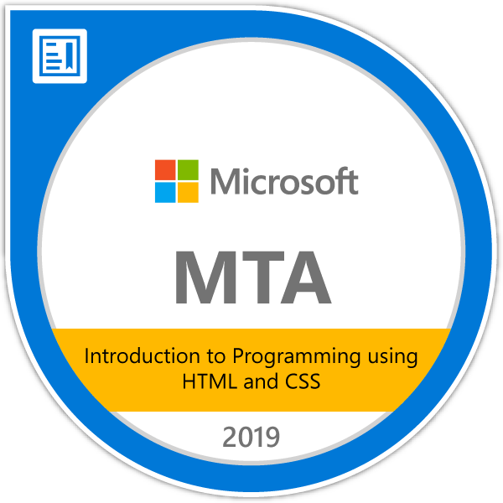

ADDITIONAL INFORMATION
Languages Spoken:
English, Gujarati, and Hindi
Interests:
Travelling and photography

REFERENCES

Pinal Desai
Team Lead, Tomahawk
Auckland, NZ
027 398 8446

Rodulfo Taer
Team Leader, Spectrum Care
Auckland, New Zealand
Telephone: 022 103 5535

